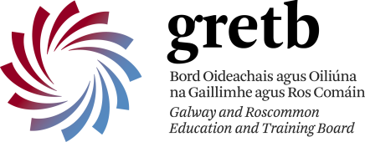 |  | Cuan na Gaillimhe CNS  - a Steiner education
An Cimín Mór, Cappagh Road Knocknacarra, Galway, H91Y38E
Roll No: 20462d Tel: (091) 867387
www.cuannagaillimhecns.ie

Admission Notice for 2023-2024
The following Annual Admission Notice has been prepared by the Board of Cuan na Gaillimhe CNS in respect of the admission of students to the school for the school year 2023-2024. This notice was published on 24/10/2022.

Application and Decision Dates for Admission to 2023/2024 School Year
The following are the dates applicable for admission to Junior Infants
- The school will commence accepting applications for admission on | 24th October 2022
- The school shall cease accepting applications for admission on | 6th January 2023
- The date by which applicants will be notified of the decision on their application is | 27th January 2023
- The period within which applicants must confirm acceptance of an offer of admission is | 10th February 2023
Note: Applications made after the 6th January 2023 will be processed as late applications, and the school will consider and issue decisions on late applications in accordance with the school’s admission policy.
Failure of an applicant to accept an offer by the 10th February may result in the offer being withdrawn.
A copy of Cuan na Gaillimhe CNS’s Admission Policy and Code of Conduct is available at | School website  http://www.cuannagaillimhecns.ie/
 | School office (for printed copy)
 | By emailing info.cng@gretb.ie
An Application Form for admission to Cuan na Gaillimhe CNS is available from 24/10/2022 at: | School website  http://www.cuannagaillimhecns.ie/
 | School office (for printed copy)
 | By emailing info.cng@gretb.ie

Other Year Groups Application and Decision Dates for Admission to 2023/2024 School Year
The following are the dates applicable for admission to other year groups (SI to 6th class)
- The school will commence accepting applications for admission to other year groups on | 7th November 2022
- The school shall cease accepting applications for admission to other year groups on | 27th January 2023
- The date by which applicants will be notified of the decision on their application is | 10th February 2023
- The period within which applicants must confirm acceptance of an offer of admission is | 24th February 2023
Note: Applications made after the 27th January 2023 will be processed as late applications, and the school will consider and issue decisions on late applications in accordance with the school’s admission policy.
Failure of an applicant to accept an offer by the 24th February may result in the offer being withdrawn.

Number of places being made available in 2023-2024
The number of places being made available in junior infants is | 28
The number of places being made available in other year groups is to be determined based on the number of vacancies in senior classes and based on our admission policy.

